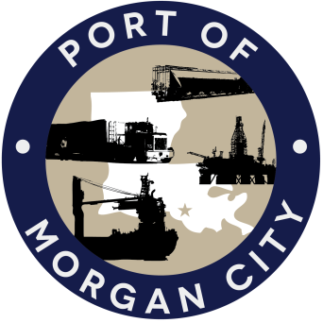

AGENDA

MORGAN CITY HARBOR AND TERMINAL DISTRICT
Regular Meeting of February 8, 2016 – 5:00 p.m. – 7327 Highway 182, 2nd Floor (EOC)

- Call to Order

- Roll Call

- Invocation

- Pledge of Allegiance

- Minutes

Regular Meeting of January 11, 2016

- Finance Report
A. Presentation and discussion of financial reports for January 2016 – Deborah Garber
B. Invoices

Guest(s)
A. United States Coast Guard
B. Corps of Engineers, New Orleans District

Raymond “Mac” Wade - Executive Director’s Report

A. Consultant – Jonathan Hird, Moffatt & Nichol
B. Consultant – Michael Knobloch, Knobloch Professional Services, LLC
C. Consultant – Clay Breaud, Providence/GSE
D. Consultant –Carl Blum, Architect
E. Cindy Cutrera, Manager of Economic Development

- Gerard Bourgeois - Legal Report

- New Business

- Old Business
A. Discussion and any action on leasing, improvements, maintenance and repairs to facility, including Coast Guard lease(s)
B. Discussion and any action regarding the U.S. Department of Homeland Security grant program, including request for proposals, bids, purchases, project management, generators, computer data system and NOAA ports system(s).
C. Discussion and any action on Government Operations and Emergency Center including bids, purchases, project agreements, change orders, inspection, payments, leasing and Facility Planning and Control
D. Discussion and any action on Atchafalaya River Channel dredging and sediment management, including survey services, consulting services and economic study
E. Discussion and any action on declaration(s) of a state of emergency and authorization to make necessary purchases and take necessary action to prevent loss of life or threats to property.

- Adjournment

In accordance with the Americans with Disabilities Act, if you need special assistance, please contact Tori Henry at 985-384-0850, describing the assistance that is necessary.

